**BIG DATA – FINAL EXAM**

Prof. Nair

November 2016

**Question 1**

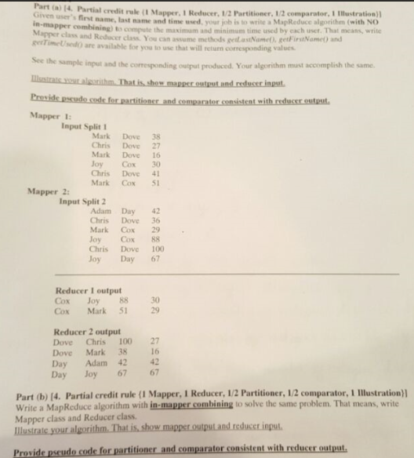

**Question 2**: Write pseudo-code for Mapper and Reducer class of **Inverted Indexing (using revised implementation)**

**Question 3**: Do the compressing for the below posting list (cannot remember the number, just take an example)

[(255, 15), (770, 12), (860, 32), (1065, 32)]

1. Use varInt method
2. Use Simple-9 method
3. Use Bit aligned method

**Question 4**: Give a text file “test.txt” as below

Mat Cat Rat <end of line>

Hat Bat Sat <end of line>

Cat Mat Bat <end of line>

**Assume**

val one = sc.textFile(“test.txt”)

1. What is the output:

val a = one.map(w => (w,1)).reduceByKey(_+_)

a.foreach(println)

1. What is the output:

val b = one.flatMap(line => line.split(“ “)).map(w => (w,1).reduceByKey(_+_)

b.foreach(println)